2020 Lismore
The Age of Grace
Viognier

This expressive viognier seduces you with the beautiful perfume of honeysuckle and orange blossom and a textured palate of apricot, kiwi and pineapple. A sensual and exotic experience. Barrel fermented and aged. Enjoy it now or allow it to gain complexity with further cellaring.

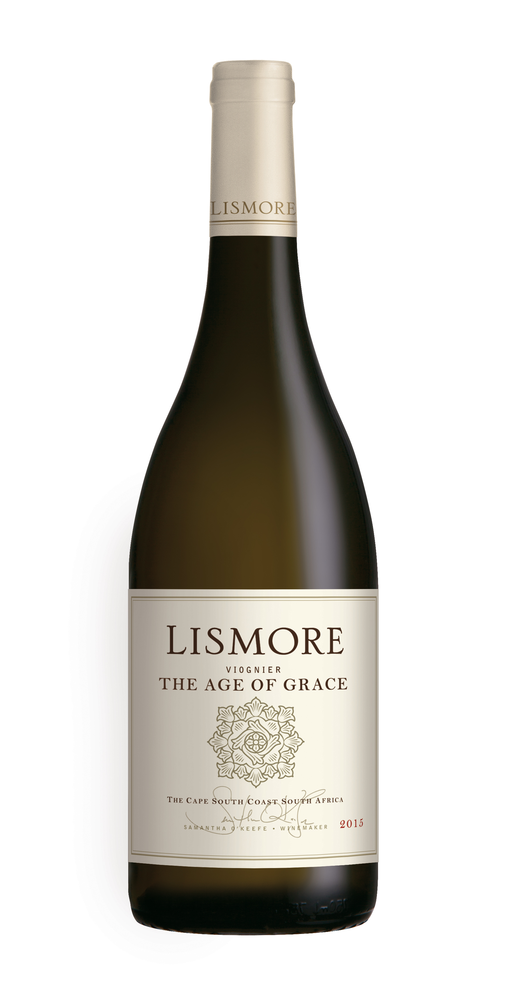

Winemaker’s Notes
The grapes were picked and whole bunch pressed, slowly extracting the juice at a rate of 550ltrs per ton. The juice was settled for 48 hours and was racked into older, neutral 225 litre Burgundian barrels, and a 600 litre egg shaped tank for fermentation and maturation lasting 10 months. The “egg” component is 10% of the production.

Wine Making Aesthetic
Balance is the key to this wine. Viognier is an aromatic and generous varietal; it benefits from barrel maturation and lees contact with a fuller mouth feel and increased texture. This combined with the firm acid backbone and intense fruit will allow this wine to integrate beautifully and gain further complexity over the next 3-5 years.

Alcohol: 14.5 % RS: 3.16 g/l Total Acidity: 6.46 g/l pH: 3.43
Wine of Origin Cape South Coast

